Here’s a few screenshots of the item listing and prices.

This is the different tables that were created. The first is a list of restaurants, and the remaining 5 are each of the restaurants.

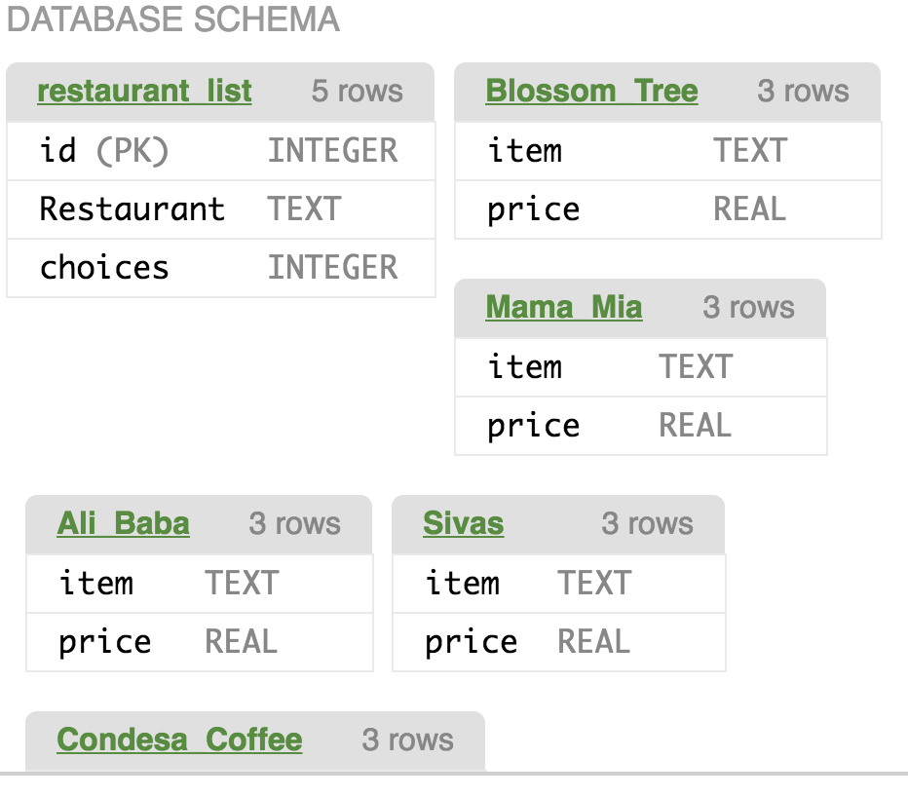

Once you click on the restaurant list table, it will pull up the 5 restaurants, showing that each one contains 3 choices.

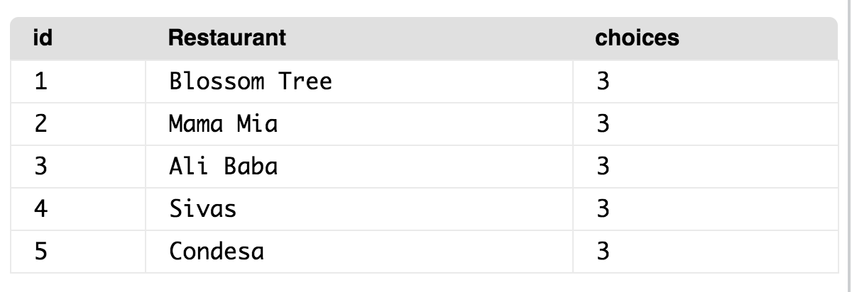

If you click on one of the restaurants in the list, it will show you 3 available items to purchase from that restaurant.

Here’s a screenshot of the first three restaurants. Blossom Tree, Mama Mia, and Ali Baba

